Problem Solving and Calculations:
Set 1

1 More than one velocity can have the same magnitude. The direction must be known to be able to fully describe the motion of the object. The direction, for example, must be known for you to know where the object ends up after travelling with a particular velocity for some time.

2a
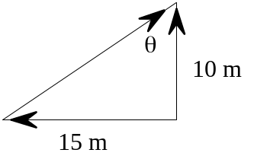 | Using Pythagras' Theorem  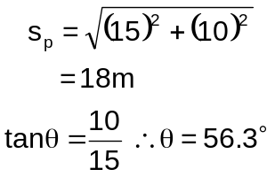  Displacement of the player is 18 m, N 56 E.

2b
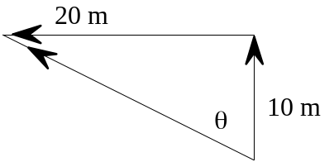 | 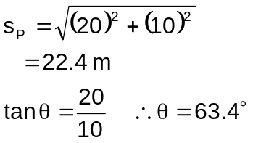  Displacement of ball is 22 m N 63° W

3
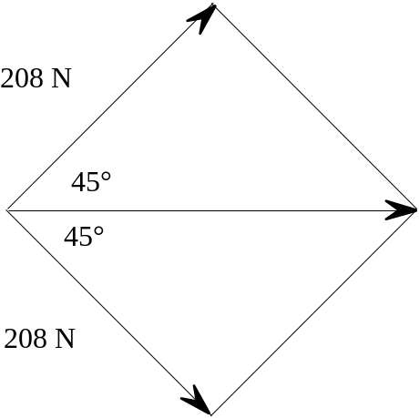 | 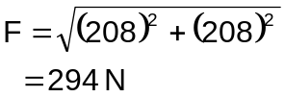  The force is 294 N in the opposite direction in which the arrow points.

4
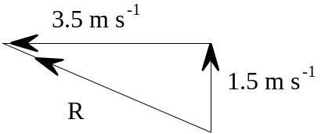 | 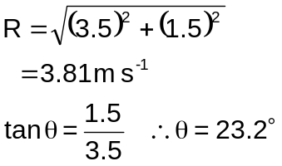  The swimmer's resultant velocity is 3.8 m s-1 at 23° to the rip.

5a
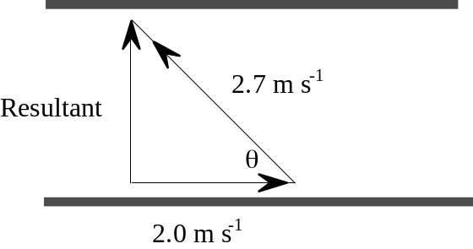 | 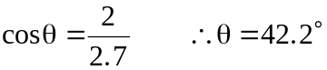  The heading must be at an angle of 42° to the current

5b
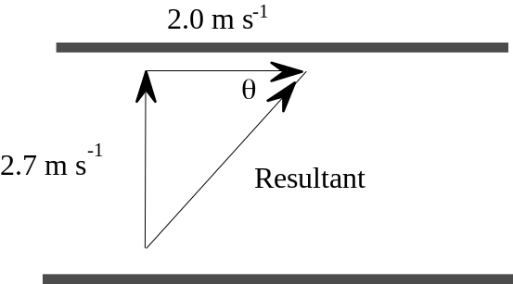 | 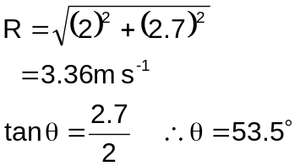  The canoeist's resultant velocity is 3.4 m s-1 at 53° to the bank

5c
s = 40 m  v = 2.7 m s-1  t = ? | 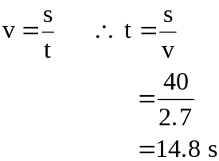 | 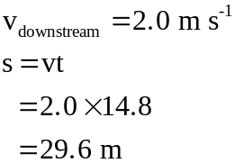  The canoeist will be 30 m downstream

6
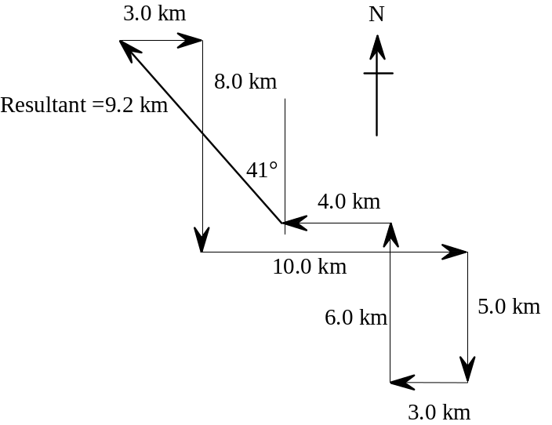 | The skier is 9.2 km from the village. She should head N 41° W or at a bearing of 391° to return to the village.

7
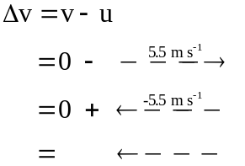 | The change in velocity is 5.5 m s-1 away from the player.

8
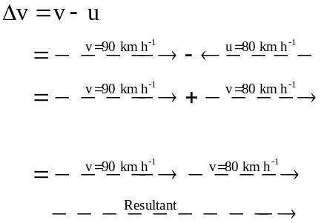  ∴R = 170 km h-1 | The change in velocity is 170 km h-1 or 47 m s-1 towards his opponent.

9
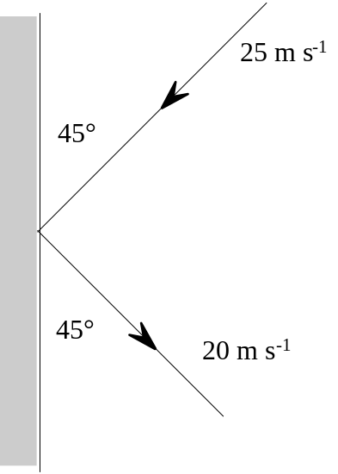 | Δv = v - u  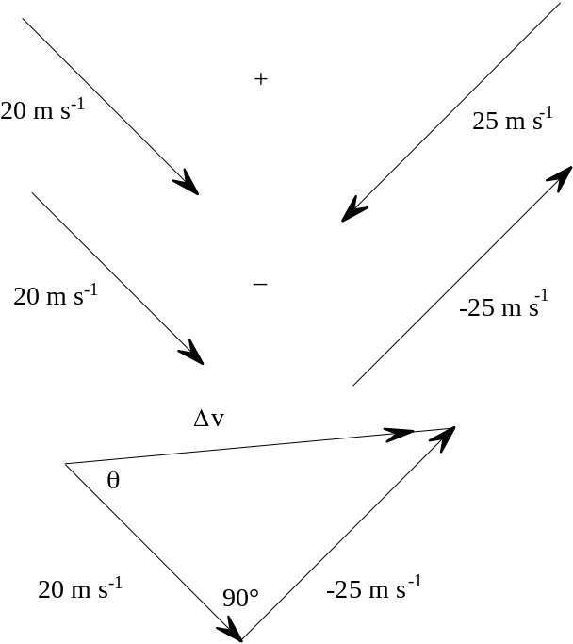  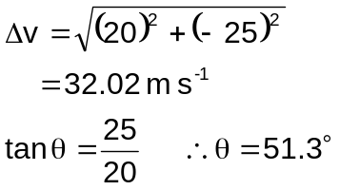  The change in velocity is 32 m s-1 at 51° to the final velocity.

10
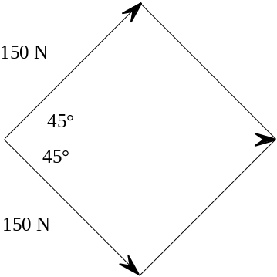 | 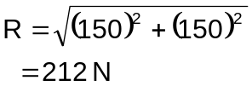  The force is 212 N directly foward.

11
Δv = v - u  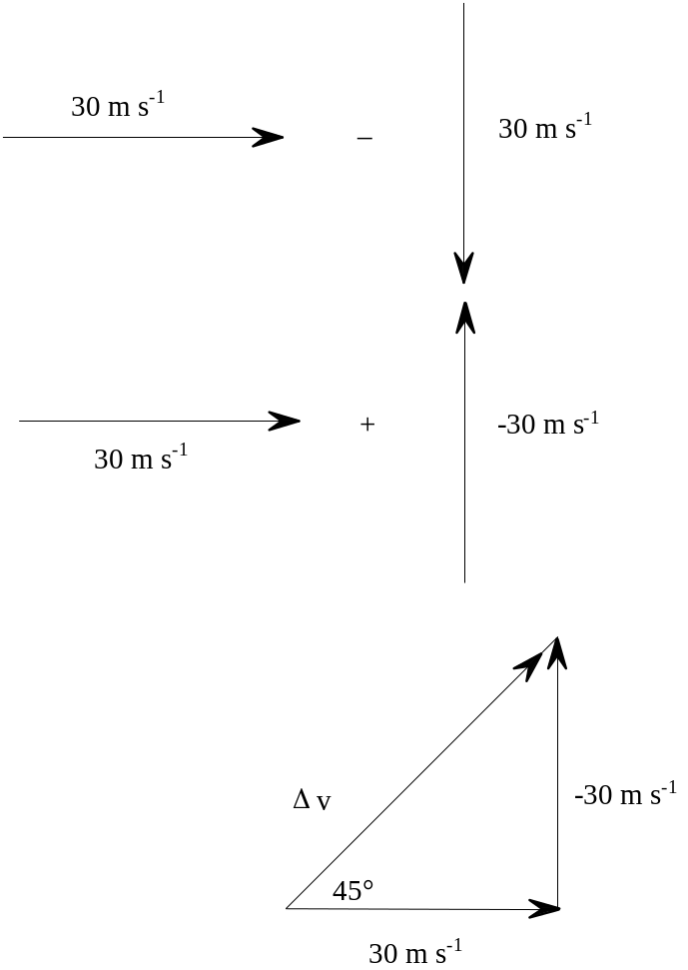 | 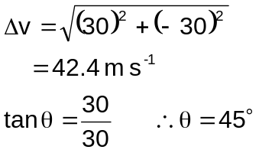  The change in velocity is 42 m s-1 at 45° to the final velocity and towards the bowler.

12 Position 1:

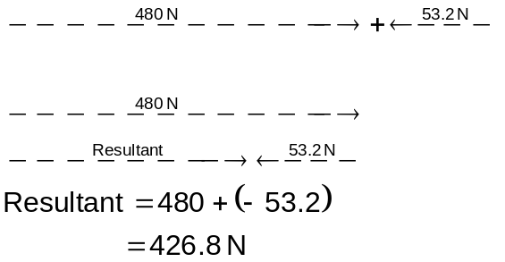

The net force on the asteroid is 427 N towards the earth.

Position 2:

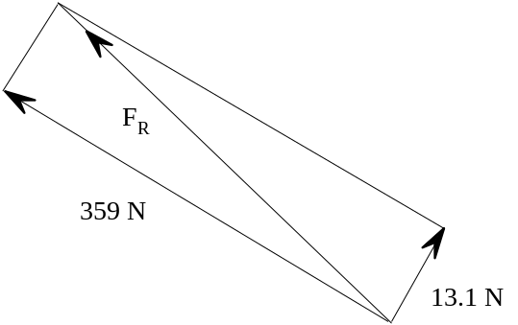 | 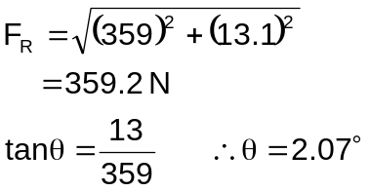  The force is 359.2 N (359 N to 3 significant figures) at an angle of 2.1° to the asteroid-Earth direction and towards the moon.

13
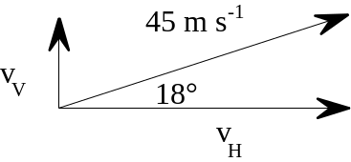 | 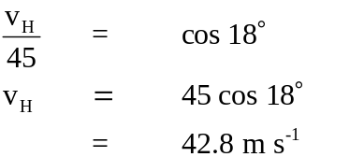  Velocity in the horizontal direction is 43 m s -1

14
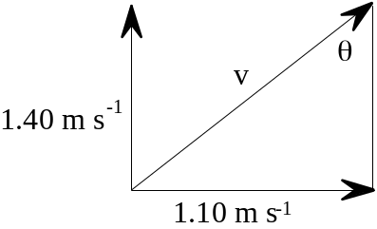 | 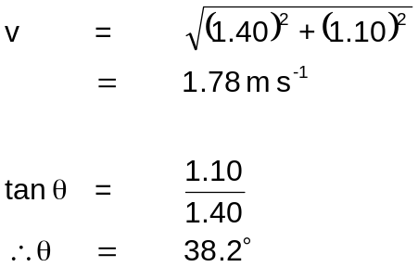  Actual velocity is 1.78 m s-1 N 38.2° E

15a
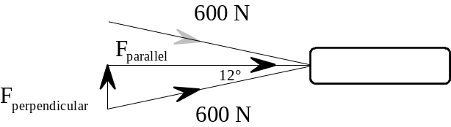 | 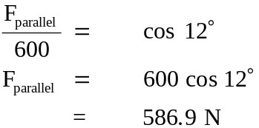  Each crew member provides the same force  ∴ total force = 2 × 586.9  = 1.17 × 103 N

b
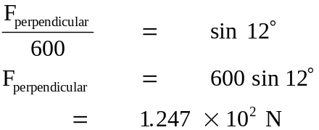

Force that each crew member applies is 125 N
16
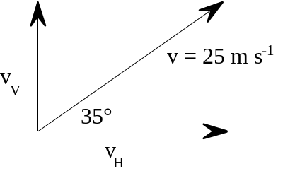 | 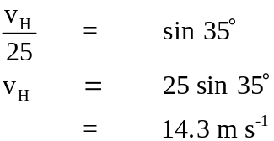  The ball is rising at 14 m s -1  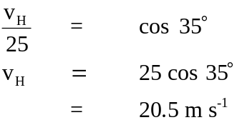  The ball is moving towards the pin at 20 m s-1

17
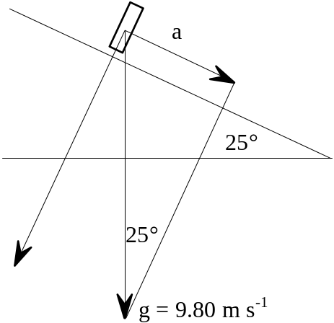 | 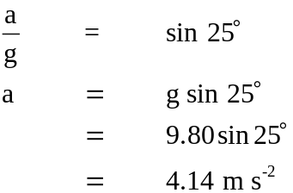

18
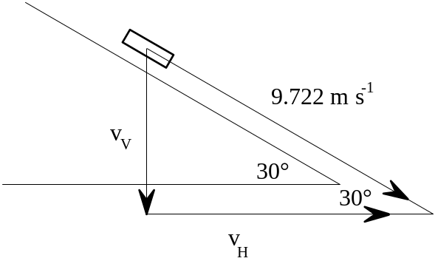 | v = 35 km h-1 = 9.722 m s-1  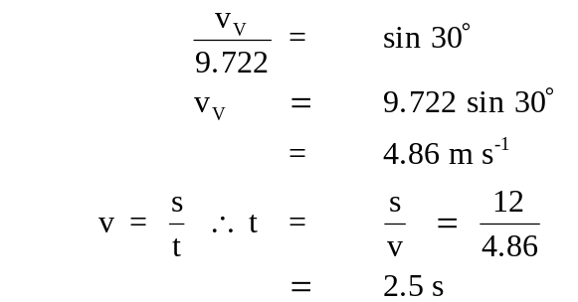  Time to descend 12 m is 2.5 s
19
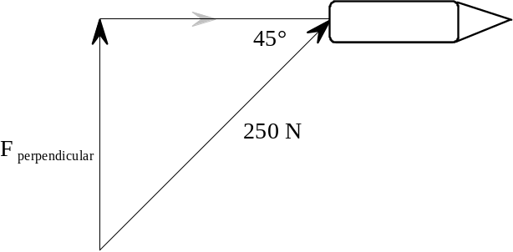 | 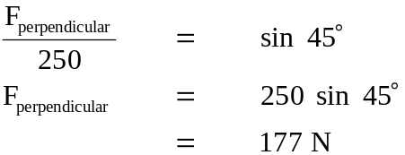  Force of 177 N must be applied perpendicular to and towards path of boat.

20a
s = 45 m  vball = 13 m s-1 | 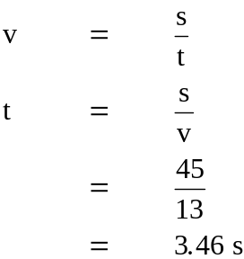

Time to get into position is 3.5 s

b
t = 3.46 s  vwind = 8.5 m s-1 | 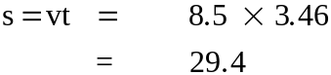

The team mate has to run 29 m

21a
If the plank is used as a ramp the perpendicular force applied to the plank is only a component of the weight force applied by the drum. The steeper the angle the smaller the force applied perpendicular to the plank.

b
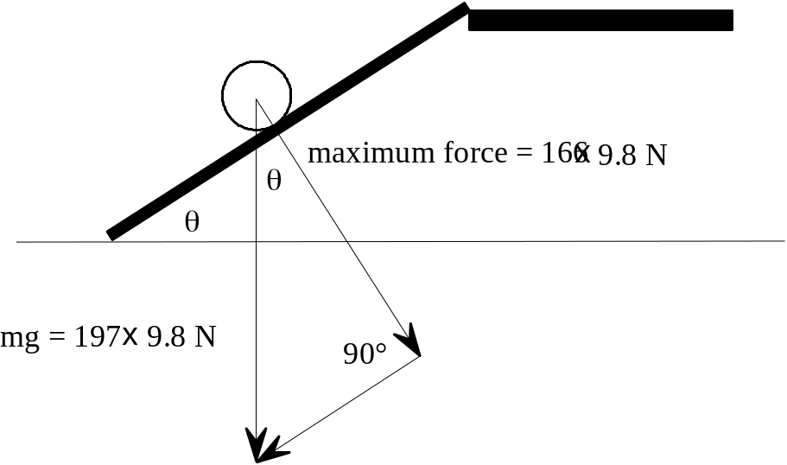 | 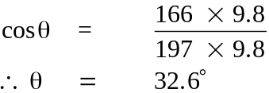  Minimum angle is 32.6°

22 Resolve each into parallel and perpendicular forces (to direction of travel)
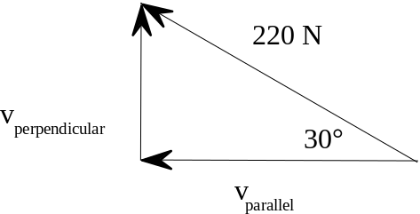 | For the 220 N force:  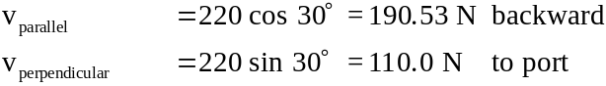

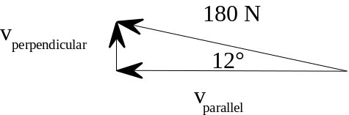 | For the 180 N force:  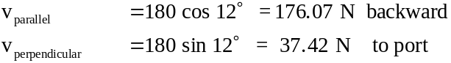

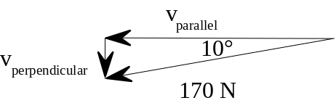 | For the 170 N force:  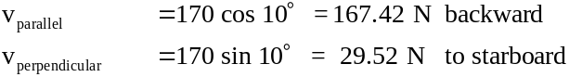

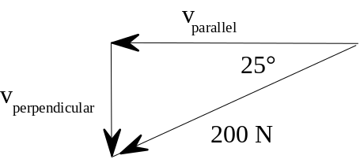 | For the 200 N force:  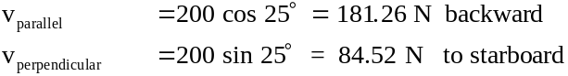

Sum all vparellel = 190.53 + 176.07 + 167.42 + 181.26
= 715.28 N backward

Sum all vperpendicular = 110.0 + 37.42 - 29.52 - 84.52
= 33.38 to port

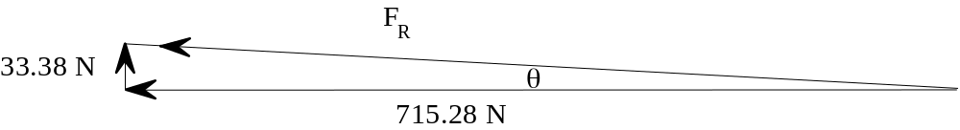

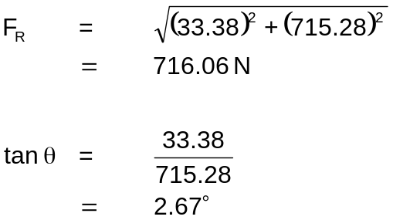

Total force applied to boat = 716 N at 2.7° to port (left)

23
